Airway Management
Basic Structural Anatomy of upper airway including the larynx

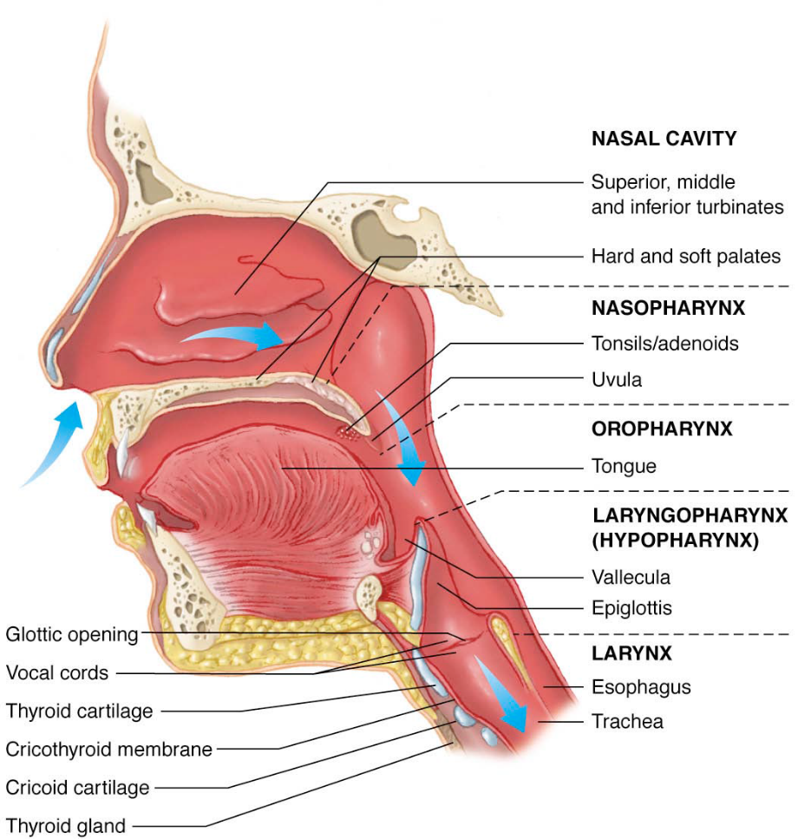

Functions
- warm, filter, and humidify air

Nasal cavity and nasopharynx
- Formed by union of facial bones
- Nasal floor towards ear not eye
- Lined with mucous membranes, cilia
- Tissues are delicate, vascular
Adenoids Lymph tissue
- filters bacteria
- Commonly infected

Oral cavity and oropharynx
Teeth
Tongue
- Attached at mandible, hyoid bone
- Most common airway obstruction cause
Palate
- Roof of mouth
- Separates oropharynx and nasopharynx
- Anterior= hard palate
- Posterior= soft palate
Tonsils
- Lymph tissue
- Filters bacteria
- Commonly infected

Epiglottis
- Leaf-like structure
- Closes during swallowing
- Prevents aspiration

Vallecula
- “Pocket” formed by base of tongue, epiglottis

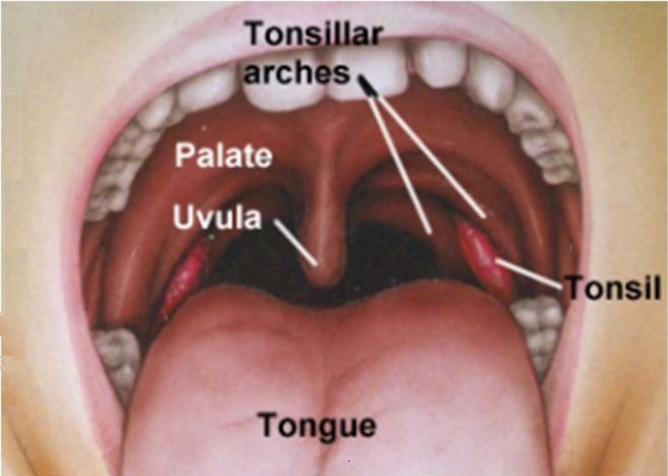

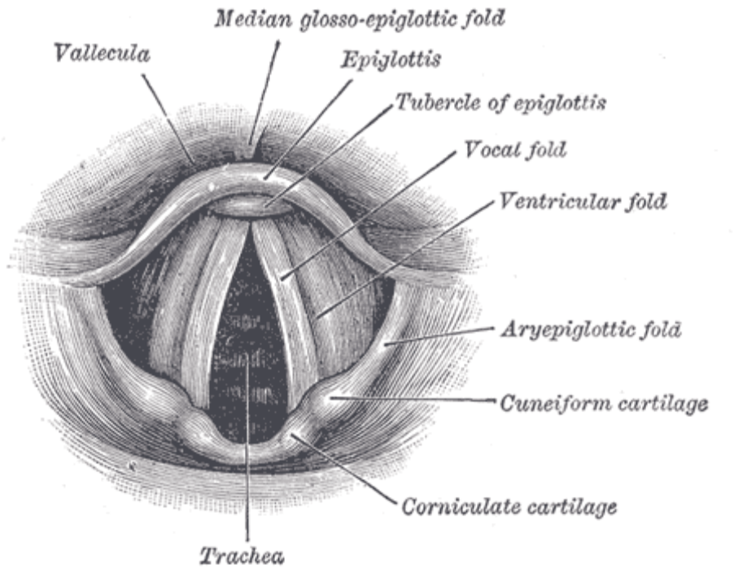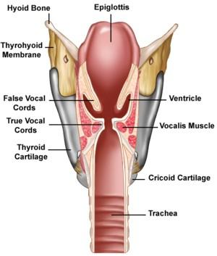

Larynx
- Attached to hyoid bone
- Horseshoe shaped bone
- Supports trachea

Thyroid cartilage
- Largest laryngeal cartilage
- Shield-shaped
- Cartilage anteriorly, smooth muscle posteriorly
- “Adam’s Apple”
- Glottic opening directly behind

Glottic opening
- Adult airway’s narrowest point
- Dependent on muscle tone
- Contains vocal bands

Arytenoid cartilage
- Posterior attachment of vocal bands

Cricoid ring
- First tracheal ring
- Completely cartilaginous
- Compression (Sellickmaneuver) occludes esophagus

Cricothyroid membrane
- Membrane between cricoid, thyroid cartilages
- Site for surgical, needle airway placement

Larynx and Trachea
- Associated Structures
- Thyroid gland
- below cricoid cartilage
- lies across trachea, up both sides

Carotid arteries
- branch across, lie closely alongside trachea

Jugular veins
- branch across and lie close to trachea

Identification of potentially difficult airway

Patient Factors
Congenital
- Eg. Down’s syndrome Poorly developed or absent bridge of the nose, macroglossia
Acquired Infections
- Supraglottis - Laryngeal oedema
- Croup - Laryngeal oedema
- Abscess - Distortion of the airway
- Ludwig’s angina - Distortion of the airway and trismus
Arthritis
- Rheumatoid arthritis
  - Temporomandibular joint ankylosis, cricoarytenoid arthritis, deviation of laynrx,
  - restricted mobility of cervical spine
- Ankylosing spondylitis
  - Ankylosis of cervical spine, less commonly ankylosis of temporomandibular joints, lack of mobility of cervical spine
Obesity
- Short thick neck, redundant tissue in the oropharynx, sleep apnea

Other
- Airway oedema,
- burns,
- bleeding,
- tracheal/oesophageal stenosis,
- compression or perforation,
- pneumothorax
- aspiration of gastric contents
Examination Findings
Mouth:
- Opening of at least 2 large finger breadths between upper and lower incisors in adults is
- desirable.
Teeth:
- Prominent upper incisors, or canines with or without overbite
  - Can impose a limitation on alignment of oral or pharyngeal axes during laryngoscopy and especially in association with a large base of tongue,
- An edentulous state can render axis alignment easier but hypopharyngeal obstruction by the tongue can occur.

Palate:
A high arched palate or a long, narrow mouth may present difficulty.

Jaw Protrusion

Thyromental length should ideally be > 6 cm
Observation of patient’s neck:
- A short, thick neck is often associated with difficult intubation.
- Assess mobility and ability to mobile neck

Presence of hoarse voice/stridor or previous tracheostomy may suggest stenosis
Any systemic or congenital disease requiring special attention during airway management
- respiratory failure, significant coronary artery disease, acromegaly

General assessment of body habitus can yield important information
Infections of airway
- epiglottitis, abscess, croup, bronchitis, pneumonia

Physiologic conditions:
- Pregnancy and obesity.
Must also recognise patients that are difficult to bag mask ventilate.
- Small face
- Edentulous
- Beard
- Large nose
- Large prominent tongue
- Large neck
- OSA – may be a risk of obstruction

Mallampati and Larynx Grading
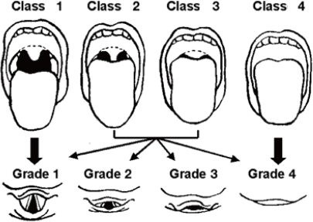
Class I : Visualization of the soft palate, fauces; uvula, anterior and the posterior pillars.
Class II : Visualization of the soft palate, fauces and uvula.
Class III : Visualization of soft palate and base of uvula.
Class IV: Only hard palate is visible. Soft palate is not visible at all

Grade I – Visualization of entire laryngeal aperture.
Grade II – Visualization of only posterior commissure of laryngeal aperture.
Grade III – Visualization of only epiglottis.
Grade IV – Visualization of just the soft palate.

LEMON airway assessment method
The score with a maximum of 10 points is calculated
by assigning 1 point for each of the following LEMON
criteria:

L = Look externally (facial trauma, large incisors, beard or moustache, large tongue)

E = Evaluate the 3-3-2 rule (incisor distance-3 finger breadths, hyoid-mental distance-3 finger breadths, thyroid-to-mouth distance-2 finger breadths)

M = Mallampati (Mallampati score > 3).

O = Obstruction (presence of any condition like epiglottitis, peritonsillar abscess, trauma).

N = Neck mobility (limited neck mobility)
Fasting Requirements

Clear Fluids – 2hrs
Light meals – 6hrs
Heavy meals – 8hrs

Reduction of aspiration risk

Predisposing factors for aspiration under general anaesthesia
Patient factors
- Increased gastric content
- Intestinal obstruction
- Non-fasted
- Drugs
- Delayed gastric emptying
- Lower oesophageal sphincter incompetence
- Hiatus hernia
- Gastro-oesophageal reflux
- Pregnancy
- Morbid obesity
- Neuromuscular disease
- Decreased laryngeal reflexes
- Head injury
- Bulbar palsy
- Gender Male
- Age Elderly

Operation factors
- Procedure Emergency
- Laparoscopic
- Position Lithotomy

Anaesthetic factors
- Airway
  - Difficult intubation
- Gas insufflation
- Maintenance
  - Inadequate depth

Prevention of Aspiration

Preoperative fasting
- Current guidelines are 2 hours for clear fluids, 4 hours for breast milk, and 6 hours for a light meal, sweets, milk (including formula) and non-clear fluids.

Reducing gastric acidity
- Histamine (H2) antagonists and proton pump inhibitors (PPIs) are commonly used to increase gastric pH
- Oral sodium citrate solution reliably elevates gastric pH above 2.5, but it increases gastric volume, and is associated with nausea and vomiting.
- H2 antagonists act by blocking H2 receptors of gastric parietal cells, thereby inhibiting the stimulatory effects of histamine on gastric acid secretion.
  - Give them 1-2hrs before anaesthesia
- PPIs on the other hand, block the ‘proton pump’ of the same cell, inhibiting the stimulatory actions of histamine, gastrin and acetylcholine.
  - Given them 12hrs in advance

Rapid Sequence Induction (RSI)
- Aspiration can occur on induction and laryngoscopy
- For patients at high risk of aspiration, a RSI is the induction of choice unless presented with a sufficiently difficult airway to warrant an awake-fibreoptic intubation.

Cricoid pressure
- First described by Sellick in 1961, cricoid pressure remains an essential manoeuvre performed as part of RSI despite significant controversy.
- The aim is to compress the oesophagus between the cricoid ring cartilage and the sixth cervical vertebral body thus preventing reflux of gastric contents.
- The force recommended is 30N
- Cricoid pressure should be released in the case of active vomiting to avoid oesophageal rupture.

Nasogastric tube placement
- Patients for emergency theatre with intestinal obstruction frequently have a nasogastric tube in situ.
- It can be useful to empty the stomach before induction of anaesthesia.

Airway device
- A cuffed endotracheal tube is considered the gold standard device used for airway protection.
  - Disadvantages - cardiovascular and respiratory instability, postoperative hoarseness, sore throat, increased length of stay in theatre
- Alternative supraglottic devices include the classic Laryngeal Mask Airway (LMA) and the Proseal LMA, the latter providing a higher seal pressure (up to 30cmH20) and a drainage channel for gastric contents – not recommended for use if concerned about protecting the airway
.
Emergence
- It should be remembered that those patients at risk of aspiration on induction are similarly at risk on emergence. Care should be taken to ensure that their airway reflexes have fully returned before extubation occurs.

Management of Aspiration

- Head down tilt
- Oropharyngeal suction
- 100% oxygen
- Apply cricoid pressure and ventilate
- Deepen anaesthesia/perform RSI
- Intubate trachea
- Release cricoid once airway secured
- Tracheal suction
- Consider bronchoscopy
- Bronchodilators if necessary

Airway strategy

Position the patient in the ‘sniffing position’ – aligns the mouth, the oropharynx and the trachea
Preoxygenate the patient with 100% O2 for at least 3 mins
Titrate anaesthetic agents (IV or inhaled) to effect,
Check eyelash reflex
Utilise jaw thrust and bag mask ventilate patient
If there is an obstruction – relieve it with either better jaw thrust, guidels airway, nasopharangeal airway, two hand bag mask ventilation

Indications for rapid sequence
A method of rapidly inducing GA and neuromuscular blockade to quickly provide optimal intubating conditions while minimizing risk of aspiration
Indications:
- Deteriorating clinical situation and acutely unwell
- Severe reflux
- Pregnant
- Non-cooperative patient
- Respiratory and ventilatory compromise
- Impaired oxygenation
- Full stomach (increased risk of regurgitation, vomiting, aspiration)
- Secretions, blood, vomitus, and distorted anatomy
Manual in line stabilisation (MILS)
The aim is to maintain the victim’s head in a neutral position aligned with the body, thus avoiding side to side movements.

The main indication is any trauma – could be blunt force or penetrating injuries particularly above the clavicle. – Spinal injuries must be assumed to be present until proven otherwise.

Maintenance of immobilization of the injured spine is of paramount importance. If a cervical spine fracture is suspected, immobilization or manual inline stabilization of the neck is necessary before the patient is moved. If the patient has a thoracic or lumbar injury, a careful log-rolling maneuver should be used

All patients with severe trauma or head injuries should be assumed to have an unstable cervical fracture until proven otherwise radiographically. During transport, the patient should be moved on a spine board with the neck immobilized to prevent further injury.

Awake fiberoptic-assisted intubation may be necessary, with general anesthesia induced only after voluntary upper and lower extremity movement is confirmed.

Blind nasotracheal intubation may be used if there is no evidence of facial or basal skull fractures.

In a truly emergent situation, oral intubation with direct laryngoscopy is the usual approach. The trachea should be intubated with minimum flexion or extension of the neck

Rapid sequence induction
Orotracheal intubation with cricoid pressure
Manual in-line immobilization of the head and neck.
Precise cervical spine in-line immobilization should be maintained throughout the intubation maneuvers.

This technique of emergency airway management involves a minimum of three, but ideally four individuals: the first to pre- oxygenate and intubate, the second to apply cricoid pressure, the third to maintain manual in-line immobilization of the head and neck and the fourth to give intravenous drugs and assist.

CICO

Vortex
LMA – variety of sizes
ETT
Laryngoscope – Variety of blades/video laryngoscope
Adjuvants – nasopharyngeal, oropharyngeal

Preoxygenation

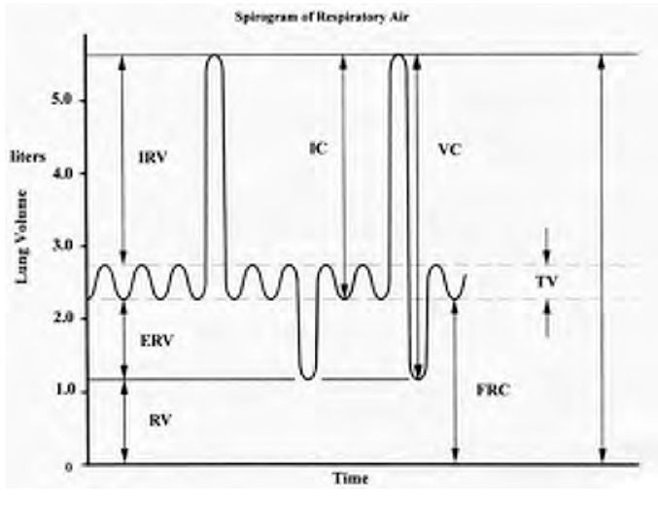
The major oxygen store within the body is the Functional Residual Capacity. A typical volume for FRC is about 2.2 litres in an average adult and normally contains 21% oxygen.
- At 21% - 460ml of Oxygen – oxygen reserve is ~1.8mins

Since total body oxygen consumption is about 250mls per minute this normal store of oxygen will only last just over 1 minute with apnoea.

Preoxygenation is defined as breathing 100% oxygen from a close fitting mask for 3-5 minutes. Breathing 100% oxygen for this time will denitrogenate the lungs and increases the oxygen store to in excess of 1800mls thus increasing the time to desaturation to about 7-8 minutes assuming an oxygen consumption of 250mls/min.

Preoxygenation is essential in patients likely to have a decreased FRC e.g. pregnant, obese Adequacy of preoxygenation can be assessed by monitoring end tidal oxygen – aim for ETO2
> 90%

Position for intubation
The correct position for the head is “sniffing the morning air”, with the neck slightly flexed and the head extended.
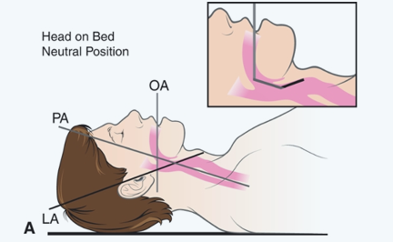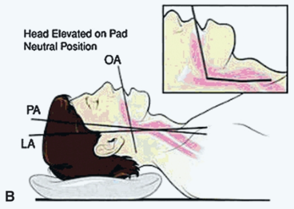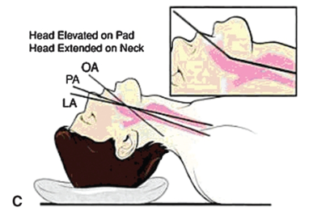
Three-axes theory
The three-axes theory postulates that, in order to facilitate DL, the oral, pharyngeal, and laryngeal axes should be aligned through patient positioning.
The classic “sniffing position” aims at aligning oral, pharyngeal, and laryngeal axes by flexing the neck over the trunk and extending the head
Complications of Intubation
- Inability to intubate the trachea in a patient who cannot ventilate spontaneously
- Incorrect endotracheal tube (ETT) placement (esophageal or bronchial intubation)
- Trauma to the airway during ETT insertion
- Aspiration of gastric contents prior to intubation
- Damage to teeth
- Compression of tracheal wall – over inflation of class
- Laryngospasm
- Bronchospasm
Complications of Extubation
- Airway obstruction
- Laryngospasm
- Aspiration
- Sore throat
- Laryngeal oedema
- Vocal chord oedema
- Vocal chord paralysis
- Incomplete reversal of opioid or paralysis
Upper airway obstruction management
Dyspnea with stridor, a loud, constant-pitch inspiratory sound that indicates obstruction of the extrathoracic airway.
Severe extrathoracic or variable intrathoracic large airway obstruction may also cause expiratory prolongation and a wheeze-like sound, making it difficult to distinguish from disease of the lower airways.
Other symptoms associated with upper airway obstruction include cough, hoarseness, dysphagia, and orthopnea, depending upon the location and nature of the obstructing lesion.
UAO may be functional or anatomic and may develop acutely or subacutely.
