General anaesthesia and sedation
- GS 1.1 Pharmacology of sedative/hypnotics, inhalational agents, opioids, muscle relaxants, reversal drugs, antiemetic agents
  - See other texts
- GS 1.2 Outline the process of induction, maintenance and emergence
- GS 1.3 Preop fasting requirements, aspiration risk, management of these
- GS 1.4 Indications for RSI
- GS 1.5 Chemical composition of crystalloids and colloids and effect when used in rescusitation
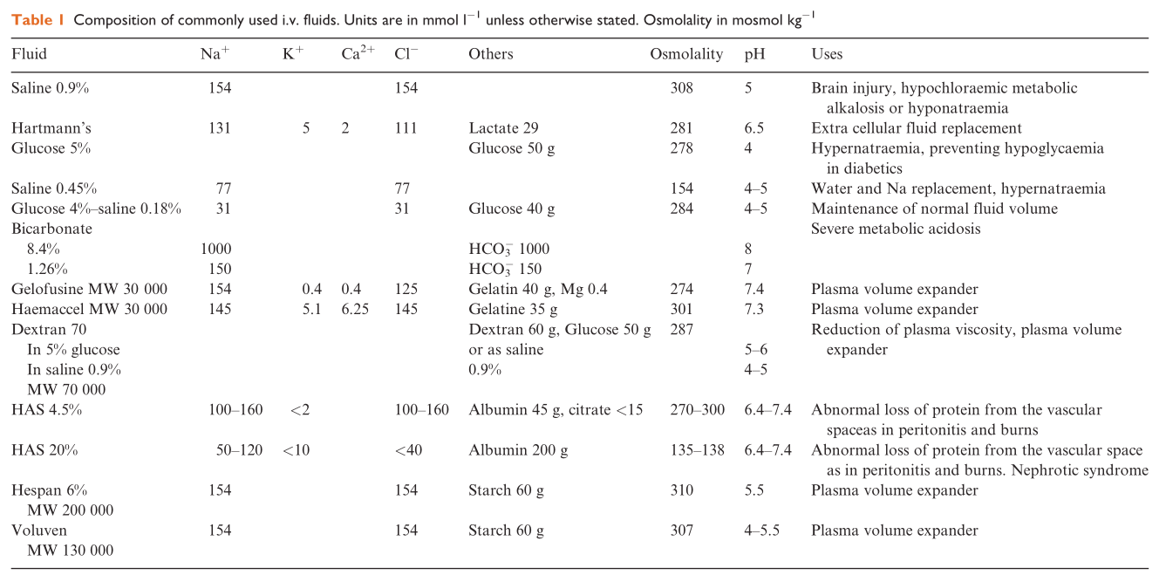
  - Crystalloids:

  - Colloids:
Colloids | Hydroxyethyl Starch | Gelatin (polygelines) | Dextrans | Plasma product (Albumin)
Composition | Modified natural polysaccharides, similar to glycogen, derived from amylopectin – corn/potato starch based.  1. To delay breakdown, hydroxyethyl groups are substituted on some of the carbons  2. C2/C6 substitution ratio – if high (>8) much slower breakdown  3. Higher molecular weight, slower breakdown | Degradation of bovine collagen, polydispersed colloidal solutions  - oxy, urea crosslinked or succynated gelatins  30-35kDa  3.5-5%  Small size = rapid clearance unchanged (80%)  Therefore fast t1/2 (1-2/24)  No accumulation | Polydispersed colloids, long chains of poylmerised sucrose synth. by Leuconostoc mesenteroides  Small dextrans <50kDa are freelyfiltered, the rest are metabolised to CO2 and H2O by liver,spleen,renal enzymes | Purified from pooled human plasma.  - Minimal infection risk  Known risk with low albumin – independent risk facto for mortality in many conditions – protective?  Used in lots of diseases, may result in worse outcomes in burns, hypoproteinaemia
Examples | Hexastarch (6 h-ethyls to 10 glucose  Hetastarch  Pentastarch  Tetrastarch – high substitution prolongs degradation  Voluven | Gelofusine | Dextran 40 – most commonly used by plastics and vascular to keep micoranastomoses alive  Dextran 70 | 4%, -isotonic  20%, 25% -  Both hyperosmotic
Effect | Vol exp  Lower blood viscosity, increased VR, CO | Vol exp  70-100% intravascular  Lower blood visc. VR/CO inc | Vol exp  Most pronounced dec blood visc, and improvement in microcirculation | Maintains IV volume. Increased COPressure

Side effects | Coagulopathy – exp high substitution starches, dec vWF (I like syndrome)  Renal damage – hyperviscous tubular flow, stasis  Taken up and stored in RES  Pruritus – up to weeks  Allergy – lowest of colloids  Anaphlaxis 1:20000 | Coagulopathy – dilutional and interference, unclear exactly.  Bovine origin – possible prion disease vector  Allergic reactions most common (x6 HES, 0.35%) | Dose dep hyperfibrinolysis, and acquired vWF synd, and dec VIII activity  Renal dysfunction – similar to HES  Anaphylaxis, therefore use (dextran 1) administered before any dextran infusion – hapten inhibitor, dec anaphylaxis chance (binds antidextran Abs without causing reaction | Same risk (high) of allergy as gelatins  Anaphlaxis 1:10000
Dose | 1.5-3.0g/kg/day slow to fast degradable respectively | No restriction | 1.5g/kg/day – to minimize coagulopathy

- GS 1.6 Calculate IV fluid requirements and choose the appropriate therapy in low risk patients and surgery
  - 4:2:1, acumen – unsure about anything higher level here apart from invasive monitoring SVV et-cetera
- GS 1.7 Describe situations where premeds are contra(indicated)
- GS 1.8 Outline the physiological changes that occur with and the implications for anaesthesia of pneumoperitoneum
  - CVS
    - Initially, mobilisation of abdominal blood volume – increased VR, slight inc in HR, CO, MAP
    - Soon followed by Decrease in VR and the opposite of the previous, with the addition of increased SVR/afterload secondary to aortic compression compounding the problem
    - With the addition of increased lung pressures and increased PVR compounding the CO of the R heart (and ergo the whole heart)
    - Esp. esp. if hypovolaemic
  - Resp
    - Decreased compliance of diaphragm – increased respiratory pressures and the cardiovascular issues that come with it, as well as the risk of barotrauma, atelectasis, impaired gas exchange and CO2 uptake from the peritoneum
  - Renal
    - Decreased RBF causing pre-renal renal insult, also causing activation of autoregulation and the RAAS syndrome and secondary sympathetic NS activation (ADH, ATII leading to further increases in SVR)
  - Hepatic
    - Decreased HBF
  - Neurological
    - Increased ICP due to limitations in cervical vein drainage as a consequence of the increased intrathoracic pressure, which is itself a consequence of the increased intraabdominal pressure.

- GS 1.9 Outline the changes and implications for Mx of the following positions: supine, trend, reverse trend, lateral, lithotomy, prone
  - Supine – decreased FRC – worse VQ matching, issues if FRC below CC, possible airway obstruction. Increased VR, increased CO, possible IVC compression in obesity/pregnancy. Increased regurgitation risk. Back pain. Occiput, heels and sacrum. Ulnar nerve.
  - Trend – as above but more extreme, with diaphragmatic splinting by gravity driven abdominal organs. Increased IOP/ICP
  - Reverse trend – improved resp, worse CVS, risk of venous air embolism
  - Lithotomy – same as supine/trend with increased venous return, hip/knee damage. Risk of tube migration/resp injury. VTE risk.
  - Lateral, as supine with underperfused and overventilated lung up top, and overperfused and underventilated lung down bottom – resp failure in resp patients possible. Corneal injuries – most common. Venous congestion inevitable in dependant arm – wary in axillary clearance. Padded legs.
  - Seated – care, CVS neck position can lead to increased ICP, Venous air embolism
  - Prone – positioning, airway, access, eyes, if abdomen free – improved FRC and VQ, if not – worse VR, and CO, and reduction in FRC. Care with arms.

- GS 1.10 Strategy for PONV
  - Apfel simplified score includes female gender, history of
PONV and/or motion sickness, non-smoking status, and post-
operative use of opioids. When 0, 1, 2, 3, or 4 factors are present,
the risk of PONV is 10%, 20%, 40%, 60%, or 80%, respectively
  - RR female ~3, RR Non-smoker ~2 (CYP induction), RR Female ~2, RR young ?, peaks at 3yo, RR N2O 1.4.
  - 1st line: CC steroids (dex), Dopamine antagonists (dror), Seretonin antagonists (ondans – all QTc prolong also, except palonosetron) all have similar RR reduction ~0.75, act independently, additive.
  - Aripepitant (NK-1 antagonist) RR 0.3 !, but expensive
  - 2nd line Metoclopramide 25-50mg, not 10mg
  - Lots of others, propofol –chose a class not had for rescue – RR reduction with a class already given is the same as placebo
  - Note, decreasing the risk: regional, TIVA, dose reduction with volatile.

- GS 1.11 Describe a safe extubation
  - More problems with extubation than intubation (4.6 vs 12.6%)
  - Awake or deep needs to be informed by 2 factors:
    - Difficult airway in any manner?
    - Aspiration risk?
  - If any difficulty suspected, ask – should the patient be woken?
  - 100% O2, PEEP breath (min atelectasis, blow detritus away from chords, end expiration
  - CVS response, resp disease needs to be considered, and also to look for and treat laryngospasm, Rfx:
    - Airway irritation/obstruction
    - Secretions/blood
    - Light anaesthesia
    - Regurgitation

- GS 1.12 Strategy for failure to wake from anaesthesia
  - Pharmacological – relating to patient variation/illness (changes in pharmacodynamics)
    - Opiates
    - Benzos
    - NMBs
    - IV hypnotics
    - Volatiles
  - Biochemical
    - Hypo/hyperglycaemia
    - Hypo/hypernatremia
    - Uraemia
    - Hypothermia
  - Systems disease
    - Respiratory failure
    - MI/CCF
  - Neurological
    - Stroke
    - Central anticholinergic syndrome
    - Dissociative coma
  - Approach?
    - ABC/100% O2, protect airway
    - GCS?, stimulate patient
    - Review chart – specific antidote?
    - BGL - treat
    - ABG – treat Na/O2/CO2
    - Temp?
    - Examine patient – look for neuro/localising signs
    - Full formal bloods
    - If still no answer – consider, where patient should be treated, specialties that need to be involved, other tests, . . . . failing that, get some subspecialist to Dx dissociative coma, or y’know, brain death.
- GS 1.13 Strategy for post op delirium
    - Same as for regular run-o-the-mill delirium
- GS 1.14 Post op pain Mx strat.
    - Gee-whiz! Pain?

