ASA

I. A normal healthy patient
II. A patient with mild systemic disease
III. A patient with severe systemic disease
IV. A patient with severe systemic disease that is a constant threat to life
V. A moribund patient who is not expected to survive without the operation
VI. A declared brain-dead patient whose organs are being removed for donor purposes
The addition of an 'E' indicates emergency surgery.

Metabolic Equivalents

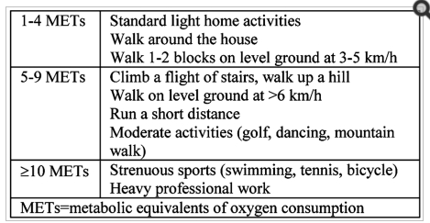

MET = metabolic equivalent. 1 MET = consumption of 3.5 ml O2/min/kg of body weight.

Life threatening Arrhythmias
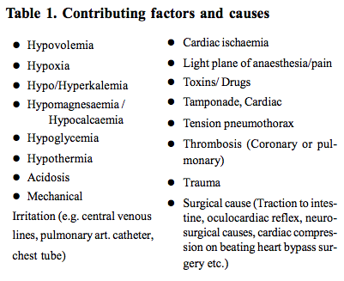

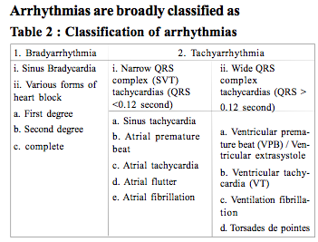
Bradycardia
Asymptomatic bradycardia usually does not require treatment.
Symptomatic bradyarrhythmias should be diagnosed and immediate therapy should follow.

Atropine
- dose of 0.5 to 1.0 mg (IV bolus)
- repeated every 3 to 5 minutes, if required (maximum dose = 0.04 mg.kg-1).

However, it should be used cautiously in pa- tients with CAD, since excessive increase in heart rate may worsen ischaemia because of increased myocardial oxygen consumption or reduced diastolic filling time.

If bradycardia still persists despite treatment:
- isoprenaline can be administered as an IV bolus of 5 to 10 g
  - followed by an infusion of 2 to 10g.min-
- Alternative: dopamine infusion 5 to 20g.min-
Heart Block
First degree and second degree don’t necessarily need treatment

Treatment is not required in narrow complex 3° block except for eradication of toxic causes.
Occasionally, permanent pacing is advocated for symptomatic, isolated AVblock. While in broad complex, pacing is indicated to maintain the normal haemodynamics

Tachycardias

Sinus Tachy
Identify and correct precipitating factors
Beta blockers

Ventricular tachy
This is defined as three or more ventricular beats occurring at a rate of 120 bpm or more. It may be potentially life threatening.
Treatment may be urgent depending on the haemodynamic situation.
If BP and CO depressed – DC cardioversion

Overall, the available antiarrhythmic drugs other than beta blockers should not be used as primary therapy in the management of ventricular arrhythmias and the prevention of SCD. The efficacy of non–beta-blocker antiarrhythmic drugs is equivocal at best, and each drug has significant potential for adverse events including proarrhythmia.

Administration of potassium and magnesium, either as intravenously in the acute setting or orally for chronic augmentation in the blood levels of these electrolytes, can favorably influence the EP substrate involved in ventricular arrhythmias.

Ventricular Fibrillation
Cardiopulmonary resuscitation must be performed as rapidly as possible. Asynchronous external defibrillation should be performed using 200-360J. A pre- cordial thump is occasionally effective in terminating VF, but should be attempted only if a defibrillator is not avail- able immediately.

Torsades de pointes
The arrhythmia is treated as follows
- Any electrolyte disturbance is corrected.
- Causative drug and precipitating factors should be stopped and removed.
- Intravenous isoprenaline may be effective when QT prolongation is acquired.
- Blockade is advised if the QT prologation is con- genital.
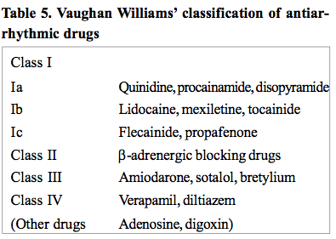

Respiratory Infection

a. Peripheral Airway Changes
i. Decreased diffusion capacity
ii. Increased closing volumes - predispose patients to intrapulmonaryshunting and hypoxemia, especially when combined with negative of volatile anesthetics effects
iii. Increased lung oxygen uptake-secondary to inflammation from infection
iv. Mechanisms of above not certain, possibly:
1. changes In hypoxic pulmonary vasoconstriction
2. changes in volume and clearance of secretions
3. changes in air flow and distribution
b. Increased Airway Reactivity
i. Secondary to released mediators associated w/infection
1. Histamine
2. Bradykinin
3. Leukotrienes
ii. Neurally mediated
1. increased vagal reflex bronchoconstriction
2.damage to M2 muscarinic receptor potentiates
release of acetylcholine at the neuromuscular junction
iii. Tachykinins increased - breakdown of these substances
1. increase vagal afferent activity
2. normally broken down by neutral endopeptidase (NEP)
3. URIs decrease amount of NEP present to breakdown tachykinins

II. PERIOPERATIVE COMPLICATIONS
a. Bronchospasm
i. May have tenfold higher risk of bronchospasm or laryngospasm
b. Subglottic edema with stridor
c. Hypoxia
d. Increased desaturation with apnea-Kinouchietal.,1992
e. Increased desaturation, but brief and treatable-RolfandCote,1992 f. Atelectasis
g. Death-KonarzewskiWHetal,1992
h. Increased risk in intubated patients-seems to be only clear consensus

III. PREOPERATIVE ASSESSMENT
a. Reasons to consider canceling an elective case in presence of a URI
i. Case requires intubation (vs mask, LMA)
ii. Case is non-emergent
iii. Productive cough, stridor, tachypnea, abnormal breath sounds
iv. Other systemic symptoms-fever, lethargy, change in activity or appetite. Even though these symptoms may not prevent one from giving an adequate anesthetic, I think that it is a shame to subject a child to the trauma of an operation when already they don’t feel well, unless the case is an emergency.
v. Concomitant illness - e.g. asthma vi. Parental preference
vii. ? environmental tobacco exposure-Parnis et al. found that passive smokers in the presence of a URI had an increased risk of adverse events.
viii. Case is an airway case: e.g. tonsils, cleft palate, etc.

VI. Reasons to proceed
a. BMT or other mask case
b. Symptoms limited to nasal congestion
c. Minimal if any cough ("post nasal drip" cough)
d. No other illness
e. Surgery is urgent

IV. Period at risk after URI
a. 4-6 weeks allows for decrease in airway hyper-responsiveness after cold/cough has resolved-this is somewhat controversial. Parnis et al., 2001, found only that cold symptoms on the day of surgery increased the risk of adverse events, NOT a URI in the six weeks prior to surgery.
b. Realistically, for upper infection alone, 2 weeks may be sufficient although minor desaturation may still be seen. One study suggests no increased incidence of laryngospasm if patient is now asymptomatic and > 2 weeks out from URI.

COPD
- routine preoperative blood tests,
- electrocardiogram to look for any evidence of right-sided heart disease or concomitant ischaemic heart disease

- The presence of extensive bullous disease on a chest X-ray highlights the risk of pneumothorax.
- Spirometry is useful to confirm the diagnosis and to assess the severity of COPD
- A baseline arterial blood gas measurement may be useful in predicting high-risk patients
- All patients with COPD require a preoperative examination, as decreased breath sounds, prolonged expiration, wheeze, and rhonchi are predictive of postoperative pulmonary complications.
- Preoperative wheezing warrants aggressive treatment with bronchodilators and possibly steroids before surgery.

- tracheal intubation and intermittent positive pressure ventilation (IPPV), is associated with adverse outcomes in patients with COPD.
- Such patients are prone to laryngospasm, bronchospasm, cardiovascular instability, barotraumas, and hypoxaemia, and have increased the rates of postoperative pulmonary complications.
- at risk of haemodynamic compromise on induction of anaesthesia and initiation of IPPV.
- Placement of an arterial catheter should be considered for both beat-to-beat blood pressure monitoring and for repeated blood gas analysis
- Preoxygenation should be used in any patient who is hypoxic on air before induction. In patients with severe COPD and hypoxia,
  - CPAP during induction may be used to improve the efficacy of pre- oxygenation and reduce the development of atelectasis.
- Limited expiratory flow rate because of airway narrowing results in the next inhalation occurring before expiration of the previous breath is complete, and leads to ‘breath stacking’ or ‘air trapping’ and the development of intrinsic positive end-expiratory pressure (PEEPi)
- The elevation of intrathoracic pressure results in:
  - decreased systemic venous return and may be transmitted to the pulmonary artery,
  - raising pulmonary vascular resistance, and leading to right heart strain.
- Along with direct pressure exerted on the heart by hyper-inflated lungs, this explains the cardiovascular instability that commonly occurs.
- Other potential harmful effects of air trapping include pulmonary barotrauma or volutrauma, hypercapnia, and acidosis
- Ways to reduce air trapping
  - Allowing more time for exhalation. Reducing the respiratory rate or the I:E ratio
  - Application of PEEP
  - Treat bronchospasm
OSA

Need to consider
- type of surgery
- requirement of opioid analgesia
- requirement of post operative monitoring or possibility of being discharged as day surgical case
If patients have congestive heart failure or hypercapnia surgery should be re-scheduled until they have been medically managed and received CPAP therapy for a pre- operative period of 3 months. CPAP therapy should be continued during hospital admission.

Patients with OSA are susceptible to the central respiratory depressant effects of benzodiazepines, neuroleptics, and opioids.
Residual neuromuscular block should be judiciously monitored and extubation was performed only in a fully awake patient.

PE

Abnormalities in respiratory function and pulmonary gas exchange are some of the first changes seen when venous emboli lodge in the lungs.

They have been attributed to an increase in alveolar dead space, or more directly to right-to- left shunting and V/Q mismatch, which may be consequences of the physical obstruction to blood flow caused by the emboli themselves.

As blood flow is shunted away from the obstructed pulmonary arteries (PAs), it then causes over- perfusion of the rest of the lung tissue, leading to edema, loss of surfactant, and alveolar hemorrhage. The resulting atelectasis develops acutely but may remain long after the emboli themselves resolve and the lung is reperfused.

Hypoxia due to pulmonary changes may be much more severe in the presence of a probe-patent foramen ovale, opened by the elevated right atrial (RA) pressure and causing a large interatrial shunt. In patients with low cardiac output (CO), low mixed venous pO2 may exacerbate the effects of shunt or V/Q mismatch on arterial oxygenation.

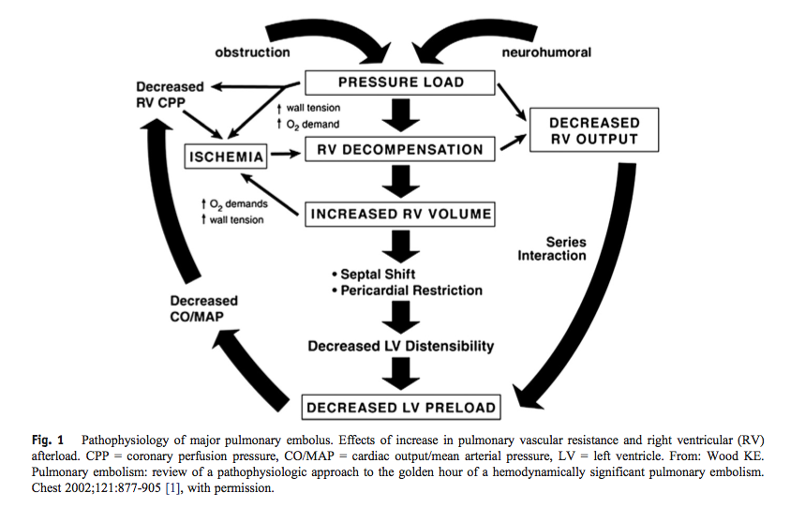

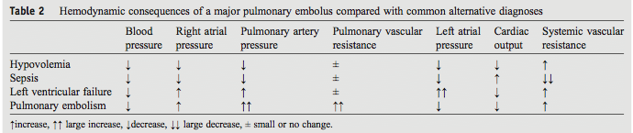

CCF

It is important that patients with congestive cardiac failure are identified pre- operatively, especially those with evidence of current or recent decompensation. Evidence of decompensation within 6 months of surgery is associated with increased risk. There may be a history of shortness of breath and reduced exercise tolerance. Patients unable to sustain 4 ‘metabolic equivalents’ (climbing a flight of stairs) are particularly at risk from perioperative complications. Associated co-morbidity such as ischaemic heart disease, hypertension and diabetes should be sought. Examination may reveal peripheral or pulmonary oedema and a third heart sound.

Transthoracic echocardiogram: This is the most useful test and can provide important anatomical information as well as an assessment of function. Heart failure can be secondary to valvular disease (usually aortic stenosis or mitral regurgitation). Patients with an ejection fraction of less than 40% are considered to have systolic failure and those with an ejection fraction of less than 30% have severe disease.
Elective surgery should be postponed until medical management has been optimised and risk assessed thoroughly against benefit. High risk patients undergoing elective or emergency surgery may benefit from preoperative optimisation in ICU or HDU

NYHA Classification
Class I: no limitation of physical activity; ordinary activity does not cause fatigue, palpitations, or syncope
Class II: slight limitation of physical activity; ordinary activity results in fatigue, palpitations, or syncope
Class III: marked limitation of physical activity; less than ordinary activity results in fatigue, palpitations, or syncope; comfortable at rest
Class IV: inability to perform any physical activity without discomfort; symptoms at rest

Perioperative management

Preserving cardiac output: There are three factors that influence cardiac output. These are preload, afterload and contractility.

Minimising myocardial work: Tachycardia increases myocardial oxygen demand and therefore should be avoided. Consideration should be given to factors which may precipitate tachycardia, including intubation, surgical stimulus, hypovolaemia, anaemia, hypoxia, hypercapnia, post-operative pain, nausea and vomiting.

With these physiological principles in mind, invasive monitoring, including cardiac output measurement, should be considered for all major surgery

Arrhythmias

Commonly see AF
Need to be rate controlled
May need to consider the safety of stopping antiplatelet or anticoagulation ie type of surgery and CHADS2 score
May be at increased risk of intraoperative cardiac events
Patients need to continue their medications for controlling arrhythmias

Conduction abnormalities ie QT prolongation – need to be careful with medications that can also increase QT eg volatiles

Pacemakers

Type
Make
Setting

Reason it was put in ie are they pacemaker dependent

Is there a defib function
When was it last checked – needs to be checked within the last 6 months

What would be the action of a magnet

Thromboembolic Disease

Electrolyte Imbalance

There are two main components to the stress response to surgery: the neuroendocrine response and the cytokine response.7 The neuroendocrine response is stimulated initially by painful afferent neural stimuli reaching the CNS.

Chronic Renal Impairment
The aim of preoperative preparation of patients with CRD is to identify and optimise any pre-existing pathophysiology in order to minimise the risk of anaesthesia and surgery. This requires a multi- disciplinary approach involving anaesthetists, sur- geons and renal physicians. Because CRD affects all organ systems, it is important to identify and optimise existing organ pathology. A systems approach is therefore useful.
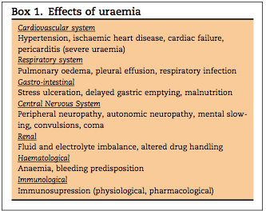

CVS
In patients with significant cardiovascular morbidity consideration should be given preoperatively to:
- Optimisation of long-term medical therapy 􏰄
- Further investigation of cardiorespiratory function 􏰄
- Preoperative optimisation in an intensive care

Vascular access:
Patients with CRD may have difficult IV access. Access should be considered and planned preoperatively.

Renal
- Usual fluid intake (may be restricted, and there- fore caution with perioperative intravenous fluids is required)
- Usual daily urine output (may be zero) 􏰄
- Regime of renal replacement therapy (e.g. frequency of dialysis) 􏰄
- Renal function (baseline and current)
  - Serum urea and creatinine concentration
  - Glomerular filtration rate 􏰄
  - Serum electrolyte concentration
  - Sodium 􏰅
  - Potassium

Timing of preoperative dialysis:
Haemodialysis and peritoneal dialysis are renal replacement therapies used to remove metabolic waste material and fluid from the circulation.
In addition, these processes also attempt to normalise fluid volume and electrolyte concentrations.

Anaesthesia and surgery should take place in a near normal physiological environment and it therefore seems logical that dialysis should take place just before surgery.
However, the dialysis process may itself cause physiological disturbance.
Effects of recent dialysis include:
- Fluid depletion and redistribution to extravascular spaces resulting in depletion of intravascular volume
- Electrolyte disturbance, especially hypokalaemia
- Residual anticoagulation from heparinisation of the haemodialysis circuit.
Dialysis is therefore usually scheduled about 12–24hours prior to surgery.

Steroid dependence

The onset of surgery is associated with the rapid secretion of hormones derived from the anterior and posterior pituitary gland. Corticotrophin (ACTH) is secreted by corticotroph cells in the anterior lobe of the pituitary gland.

Therapy with glucocorticoids results in suppression of pituitary–adrenal function. Failure of cortisol secretion is due primarily to inhibition of synthesis and secretion of corticotrophin (ACTH) [32–35], as a result of inhibited transcription of the corticotrophin gene [33, 36]. Pitui- tary–adrenal function in patients receiving steroid therapy can be assessed by considering the dose and duration of therapy and measurement of basal plasma cortisol concen- trations, but these variables may not be reliable

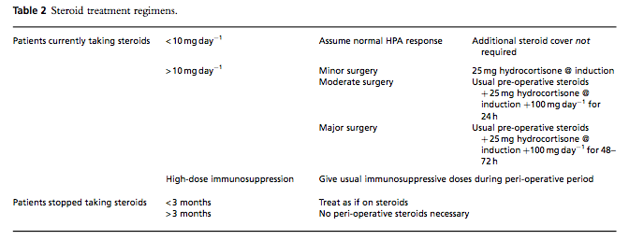

Immunocompromised patients

The immune system is divided into two major compo- nents, the innate system and the adaptive system1,3. The innate immune system is the first line of defense for a host and it does not require prior exposure to the offending agent. The key elements of this system are phagocytic ce- lls, natural killer cells, the complement system and other circulating and secreted proteins. The phagocytic cells in- clude neutrophils, macrophages, and monocytes. The ada- ptive system is a highly specific system with more dela- yed response. The response of this system becomes more rapid after memory to specific antigen has been develo- ped. The key elements of this part of immune system are lymphocytes, antigen presenting cells, humoral mediators and cytokines. The adaptive immune system also has two portions based on the primary type of lymphocytes invol- ved, T cells or B cells.
Immunodeficiency can be broadly characterized as con- genital (primary) or acquired (secondary)1,3.

Congenital deficiencies can affect both innate and adap- tive immune system. Disorders of the innate immune sys- tem are less common than those of the adaptive system4. Usually, they present during childhood with infections ca- used by common pathogens that are unusually severe, or as opportunistic infections.

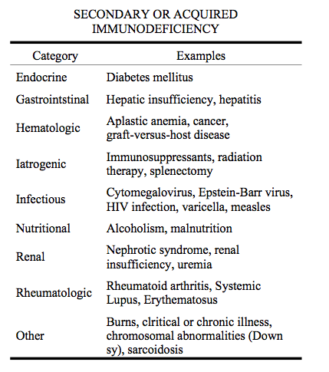

Immunocompromised patients are prone to infections – care needs to be taken
May have renal impairment or respiratory complications of the medications they are on

Usually don’t need to change the anaesthetic
Pharmacodynamic interactions are easily managed by avoiding anaesthetic agents that may potentiate side effects such as renal and hepatic dysfunction

Most of them, other than being prone to the infectious complications, require usual anesthetic appro- ach. However, some of them are challenging and anaes- thetist being involved in their management should be aware of the particular problems that may arise during the treatment.

Rheumatoid Arthritis

- A thorough history of the RA including duration of the disease, severity, drug treatments and systemic complications should be taken. Rheumatoid patients are often in pain and suffer with deformities that restrict simple movements; care should be taken during examination.
- The range of movement of all joints should be noted so as to optimise patient position and minimise injury during anaesthetic procedures (venous access, nerve blocks) and positioning for surgery. Involvement of the joints of the wrists and fingers may limit function enough to preclude the use of a standard patient-controlled analgesia (PCA).
- These patients have very fragile skin that is easily damaged. Fragile veins makes peripheral venous access unreliable and central venous access is often difficult due to neck deformity. Preoperative neurological deficit, if any, should be documented. Patients taking more than 10 mg prednisolone per day should be given appropriate peri- operative steroid cover. Patients should continue their regular prednisolone and receive hydrocortisone intra-operatively to cover the stress response to surgery. Depending on the type of procedure, hydrocortisone may need to be continued into the postoperative period as shown in Appendix 1.
- Patients are likely to have anaemia (normocytic normochromic anaemia due to chronic disease or microcytic anaemia due to gastric bleeding and drug toxicity of bone marrow) and there may be increased requirement for red-cell transfusion. Patients may have cachexia, which is indicative of poorly controlled disease and an increased long-term cardiovascular risk. Cachexia and poor muscle bulk may also indicate myopathy which may impair respiratory muscle function, and such patients may need to be considered for postoperative mechanical ventilation.
- Methotrexate can be continued in the peri-operative period without impaired wound healing or a substantially raised risk of peri-operative infection1. Furthermore, good disease control in the peri-operative period is beneficial. There is lack of data regarding the use of other immunosuppressants. Peri-operative discontinuation of biological therapy for elective surgery remains controversial. Recent studies have suggested that their use does not cause specific adverse effects and may improve recovery from postoperative anaemia.

Pre operative investigations
- Routine full blood count, renal function and electrolytes.
  - Liver function tests in patients on long term disease modifying anti-rheumatic drugs (DMARDs).
- Low threshold for ordering respiratory investigations (chest radiographs, arterial blood gases and lung function tests) due to the possibility of pulmonary involvement or respiratory myopathy.
- An ECG should be performed to check for left ventricular hypertrophy and conduction disturbances.
- An echocardiogram should be performed to look for evidence of diastolic dysfunction, left ventricular hypertrophy and valvular abnormalities. Left ventricular ejection fraction may be normal and falsely reassuring in the presence of diastolic dysfunction.

Tobacco Use

CVS
Nicotine stimulates the adrenal medulla to secrete adrenaline. It resets the aortic and carotid body receptors to maintain a higher blood pressure. It also stimulates the sympathetic system which results in an increase in heart rate, blood pressure and peripheral vascular resistance. Myocardial contractility is increased, leading to an increase in oxygen demand and consumption. Nicotine increases intracellular calcium during ischemia. This may exacerbate myocardial cell damage.

RESP
Smoking affects oxygen transport and delivery. Irritants in smoke increase mucus secretion. The mucus becomes hyperviscous, with altered elasticity. Cilia become inactive and are destroyed by ciliotoxins. The result is impaired tracheobronchial clearance (8). The integrity of the epithelium is lost because of the irritants in the smoke which result in increased reactivity. Smoking leads to narrowing of small airways, causing an increase in closing volume. There is also an increase in proteolytic and elastolytic enzymes leading to loss of elasticity and emphysema. The risk of lung infection is increased. 25% of smokers suffer from chronic bronchitis (2).
The incidence of chronic obstructive airway disease is higher in smokers.

Effects of general anaesthesia on smokers
Central respiratory depression
Reduced compliance
Cranial shift of diaphragm
Atelectasis
Decreased FRC( Functional residual capacity) FRC may exceed closing capacity
Impaired oxygen exchange
Increased shunt
Increased V/Q mismatch
Increased A –a difference

Pre-operative assessment and smoking cessation
- Patients are advised to quit smoking at least four to six weeks prior to surgery. Abstinence for twelve hours is sufficient to get rid of carbon monoxide.
- Ciliary function improves and nicotine levels return to normal within 12-24 hours. Abstinence for 2 weeks helps return sputum volume to normal levels.
- Laryngeal and bronchial activity is better in 5-10 days.
- Improvement in small airway narrowing is seen in 4 weeks but it takes 3 months to see changes in tracheobronchial clearance.

Interestingly, stopping smoking in asthmatics may worsen their symptoms and cessation for a brief period increases the risk of laryngospasm and bronchospasm during anaesthesia.
Stopping smoking is also associated with anxiety and withdrawal symptoms. Smoking poses a significant risk factor for post-operative pulmonary complications. Smokers are more prone to post-operative atelectasis, which delays the recovery and predisposes the patients to pneumonia. Also there is an increased incidence of intensive care admissions.

Anaemia
Anemia may be a known problem or a suspected possibility based on a patient's history of underlying medical conditions or the reason for surgery. It is useful to determine the etiology, duration, and stability of the anemia, related symptoms, and therapy (especially transfusions), although the evaluation needs to consider the extent and type of surgery, the anticipated blood loss, and the patient's comorbid conditions that may influence oxygenation or be affected by hypoxia, such as pulmonary, cerebrovascular, or cardiovascular disease. Inquiring about a personal or family history of anemia is important.

Coagulopathy
Hypocoagulable states are either inherited disorders such as the hemophilias and thrombocytopenia or are acquired disorders secondary to liver disease, malnutrition, or drug exposure. To determine the diagnosis and risk of bleeding, one inquires about known diagnoses, tests, treatments, previous bleeding episodes, and family history. Asking about excessive bruising, prolonged bleeding after cuts, heavy menstrual cycles, and bleeding gums is sensitive but not specific.

SLE
Preoperative evaluation determines whether the patient has chronic fatigue, weakness, respiratory compromise, fevers, and migratory arthritis affecting primarily the small joints of the hands and feet, which is common. Fevers may be a result of the disease itself or the frequent infections that develop because of the immune dysfunction and immunosuppressants used to treat the disease. Many patients have dermatologic conditions, including alopecia, the typical “butterfly rash” across the cheeks and nose, and photosensitivity. Vasospasm of the digits, dubbed Raynaud's phenomenon or disease, often with atrophy of the nails and fingernails, makes it difficult to obtain pulse oximetry readings.
Preoperative evaluation for interstitial lung disease, pleural effusions, frequent infections, and pulmonary hypertension is important and presents a significant concern. Pulmonary hypertension can result from interstitial lung disease, recurrent pulmonary emboli, or cardiomyopathy and carries a high risk of perioperative complications (see “Pulmonary Hypertension”). Cardiac involvement includes premature coronary artery arterosclerosis, pericarditis, myocarditis, aseptic endocarditis, and pleural effusions.
Coronary vasculitis and cardiomyopathy may occur. Hypertension, frequently difficult to control, is almost ubiquitous. Neuropsychiatric manifestations consisting of cerebral vasculitis, stroke, cognitive dysfunction, seizures, peripheral neuropathy, headache, affective disorders, and carotid artery disease are common. Lupus nephritis is a common morbidity with a poor prognosis that frequently results in renal failure. Patients with SLE often have anemia and may have leukopenia and thrombocytopenia.

