C Circulation, Capnograph, and Colour (saturation)
O Oxygen supply and Oxygen analyser
V Ventilation (intubated patient) and Vaporisers
E Endotracheal tube and Eliminate machine
R Review monitors and Review equipment
A Airway (with face or laryngeal mask)
B Breathing (with spontaneous ventilation)
C Circulation (in more detail than above)
D Drugs (consider all given or not given)
A Be Aware of Air and Allergy

SWIFT CHECK of patient, surgeon, process, and responses.

Dyspnoea
Dyspnea indicates an inability to obtain sufficient oxygen using normal respiratory effort.

The most common causes of respiratory distress during anesthesia include:
􏰂 􏰂
- Equipment problems (empty oxygen tank, flowmeter turned off, damaged circuit)
- Airway obstruction (ET tube blockage, laryngospasm, aspiration)
- Respiratory disease (pleural effusion, pulmonary edema, diaphragmatic hernia, etc)
- Excessive anesthetic depth such that vital functions are compromised.
􏰂 􏰁
Management

- Check SpO2 reading.
- Quickly evaluate other vital signs and anesthetic depth and equipment setup. 􏰁
- Once oxygen delivery to the patient and patent airway has been confirmed, turn the vaporizer off and ventilate with 100% oxygen until mucous membrane color and SpO2 readings return to normal. 􏰁
- Monitor closely during resuscitative efforts to ensure cardiac arrest does not occur.

Hypoxia

Equipment
- Mechanical failure of anaesthetic machine to deliver O2
- Mechanical failure of ETT – may be in main stem bronchus
- Hypoventilation – not setting values appropriate for patient

Surgical
- Required position
  - Supine
  - Head down
- Embolus – fat, cement

Patient
- Increased airways resistance
  - Anaphylaxis
  - Fibrosis
  - Bronchospasm
- Decreased CO and Increased O2 consumption

Other
- High inspired O2 – absorption atelectasis
- Excessive IV fluid administration – pulmonary oedema

Management
- 100% O2
- Assess other vital signs
- Call for help
- Check Airway
  - Tube position
  - Tube kinking
  - Still fogging/CO2 trace
- Check breathing
  - Listen to chest
    - ?wheeze, no sounds, unilateral sounds
- Check circulation
  - Other vitals ie BP, HR – treat as appropriate

Hypercapnoea/hypercarbia
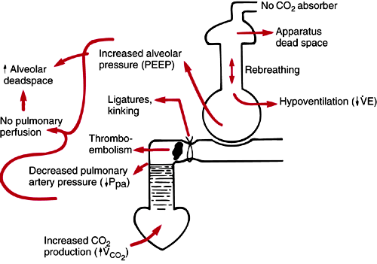
- Hypoventilation
- Rebreathing – no CO2 absorber
- Increased alveolar deadspace – V/Q mismatch
- PE
- Increased CO2 production – hypermetabolic state, hyperthermia, shivering

Hypocapnoea/hypocarbia
- Hyperventilation
- Decreased CO2 production – decreased BP/ decreased CO, hypothermia

Tachycardia

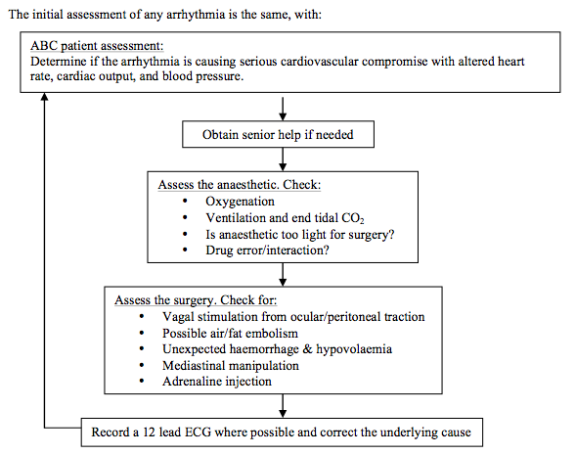

Sinus Tachycardia
Causes can be multi-factorial. Operative causes are pain, surgical stimulation and light depth of anaesthesia. Pharmacological factors include administration of catecholamines, atropine, or ketamine. Medical factors such as sepsis, hypovolaemia, heart failure, anaemia, and thyrotoxicosis should also be considered.
The management process should consider and correct the precipitating cause.

SVT

Unstable
Anaesthetised patient
- synchronised DC cardioversion with 200J, increased to two shocks at 360J if refractory.
Non- anaesthetised patient,
- sedation with a benzodiazepine and synchronised DC cardioversion is needed.

Stable
Vagal manuvres
- carotid massage
- valsalva
Pharmacological
- Adenosine
  - 6mg IV bolus
  - second and third dose 12mg with 1 minute interval
- Beta-blockers
  - Esmolol 50-200ug/Kg/min IV
  - Metoprolol 3-5mg IV over 10 minutes every 6 hours.
- Verapamil 5-10mg IV over 2 minutes, with a second dose of 5mg after 10 minutes if needed.
- Amiodarone 300mg IV over 1hour via a central line should be considered when the above interventions have failed.
- Digoxin should be avoided due to its facilitation of AV accessory conduction in Wolff- Parkinson-White syndrome and can worsen tachycardia. AF with an anatomical accessory pathway with rapid conduction can degenerate into ventricular fibrillation.

Rapid AF
- Correct any correctable causes e.g. electrolyte disturbance.
- Amiodarone 300mg IV over 1 hour via a central line (or large peripheral line in emergencies but beware risks of extravasation). Follow with 900mg over 23 hours.
- Beta-blockers (esmolol, sotolol, or metoprolol 5mg IV) slow ventricular rate and are useful before or in theatre whilst waiting for other drugs to take effect.
- Digoxin 500ug IV over 20 minutes, repeated in 4-8 hours. Max 1-1.5mg.
- Flecainide 2mg/Kg (max 150mg) IV over 30minutes with cardiac monitoring is the best drug for cardioversion back to sinus. However, it cannot be used if there is structural/ischaemic heart disease.
If the patient is haemodynamically unstable, synchronised DC cardioversion should be considered at 200J, increased to 360J if necessary for a further two shocks. Synchronisation ensures the shock is not delivered on a T wave, which avoids the risk of precipitating ventricular fibrillation. It is successful in <20% of cases.

Bradycardia

Bradycardia can often be normal finding in athletic patients or patients with high vagal tone, and it is seldom necessary to correct in fit patients until the rate is <40 beats per minute (bpm).

Surgical factors
- vagal stimulation by anal or genito- cervical dilatation.

Medical causes
- cardiac in origin
  - myocardial infarction
  - sick sinus syndrome
- non-cardiac
  - hypothermia
  - raised intracranial pressure
  - hypothyroidism.

Pharmaceutical
- Direct
  - beta-blockers
  - digoxin
- Indirect effects
  - drug side effects of halothane or anticholinesterases such as neostigmine

Management

Management must always be to correct any reversible causes first.
Atropine (up to 20μg/kg) or
Glycopyrronium (10μg/kg)

If the bradycardia is resistant to the above and the patient is known to take beta-blockers, consider adrenaline or isoprenaline by infusion (0.5-10μg/min).

If the bradycardia is entirely drug resistant, a pacemaker is required.

Hypertension

- Drug errors
- Awareness or light anaesthesia
- Pre-existing hypertension
- Airway problem
- Surgical stress
- Hypercarbia
Unusual/uncommon
- Pheochromocytoma
- Hyperthyroidism
- Malignant hyperthermia
- Raised ICP
- Fluid overload

Management
Treat the underlying cause:
Complete COVER ABCD - A SWIFT CHECK
Confirm the blood pressure change is real
Deepen anaesthesia/assess depth Cease any vasopressor therapy
Inform and interrogate the surgeon; cease stimulation
Recheck for drug errors and delivery of anaesthesia
Consider an appropriate dose of opioid
Consider antihypertensive therapy – with caution

Hypotension

Hypovolaemia
- Blood loss
- Dehydration
- Diuresis
- Sepsis
Ensure: Adequate IV access, fluid replacement, cross match

Drugs
- Induction and inhalational agents
- Opioids
- Suxamethonium
- Anticholinesterases
- local anaesthetic toxicity
- vancomycin
- vasopressor/vasodilator infusion problem
- drug ampoule or syringe error and drugs given by surgeon
Ensure: Agent ceased, support circulation

Regional Anaesthesia
- Vasodilation
- Bradycardia
- respiratory failure
Ensure: Volume loading, vasopressors (early adrenaline), airway support, left lateral displacement during pregnancy.

Surgical Events
- Vagal reflexes
- obstructed venous return
- pneumoperitoneum
- retractors and position
Ensure: Surgeon aware.

Cardiopulmonary Problems
- Tension pneumothorax
- Haemothorax
- Tamponade
- embolism (gas, amniotic or thrombus)
- sepsis
- myocardial depression (from drugs, ischaemia, electrolytes, trauma)

Ensure: Review of appropriate pages in manual.

Management
Complete COVER ABCD - A SWIFT CHECK
Confirm the blood pressure change is real
Don’t hesitate to treat as Cardiac Arrest
Inform and discuss with surgeon
Recheck vaporisers are off
Improve posture: lie flat, elevate legs if possible
IV fluids: crystalloid bolus - 10ml/kg, and repeat as necessary
Give vasopressor: metaraminol 0.005 - 0.01 mg/kg IV bolus
If severe give adrenaline 0.001 mg/kg IV bolus; Followed if necessary by an infusion of adrenaline starting at 0.00015mg/kg/min
If erythema, rash or wheeze is evident ➠ Anaphylaxis
If bradycardic give atropine
If pulseless go to Cardiac Arrest
Increase monitoring – ECG if not already present, Arterial pressures, CVP, filling pressures

High Airway Pressures

Possible causes of high pressure include airway obstruction, reduced compliance, increased resistance, oxygen flush activation during the inspiratory phase, a punctured ventilator bellows, occlusion or obstruction of the expiratory limb of the breathing system, scavenger malfunction, or the patient coughing or straining

- Lung Compliance
- Breathing Circuit Compliance
- Airway Resistance
- Ventilator Settings
- Patient position
ABCDs
Off ventilator – see if easy to ventilate if not call for help
Consider causes
Anaphylaxis
Bronchospasm

Non-compliant respiratory system (COPD, asthma, trendeleburg and lithotomy positions).
Increased resistance in the breathing circuit (kinks)
Increased resistance in the airway
Inspiratory gas flow is high

Oliguria/Anuria

Oliguria: 100–400 mL/day
Anuria: <100 mL/day
Absolute anuria: nil

CARDIOVASCULAR CAUSES OF OLIGURIA
Hypovolaemia
a. Haemorrhage
b. Vomiting or diarrhoea
c. High nasogastric or other drain losses
d. Diuretic therapy
e. Pulmonary oedema

Decreased Systemic Vascular Resistance
a. Sepsis
b. Antihypertensive medications
c. Side effects of other drugs, e.g. ACE inhibitors

Cardiac Pump Failure
a. Acute myocardial infarction
b. Arrhythmias
c. Cardiomyopathy
d. Cardiac tamponade
Cardiac Arrest

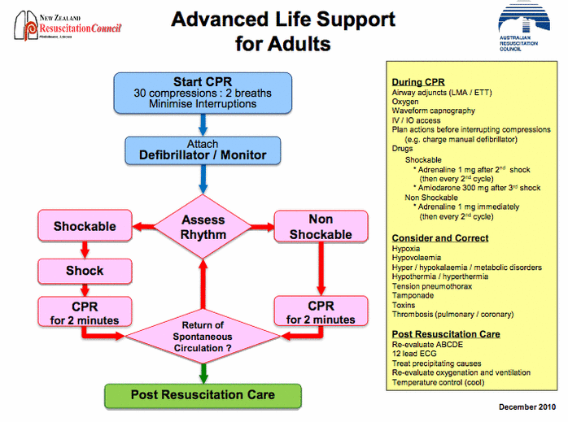

Shockable – VT, VF
Non-shockable – PEA, asystole

Respiratory Arrest

- Management of respiratory arrest includes the following interventions:
- Give oxygen Open the airway
- Provide basic ventilation
- Provide respiratory support with the use of artificial airways
- Suction to maintain a clear airway
- Maintain airway with advanced airways

No need for CPR if not accompanied with cardiac arrest
Management is focused on good ventilator support while assessment of the cause of respiratory compromise.

Shock
Hypovolemic
Tachycardia
Weak, Thready Pulse
Hypotension with Narrow Pulse Pressure
Hypotension or Falling Systolic B/P
Pale Skin
Clammy or Dry Skin
Dyspnea
Altered LOC/ Coma
Decreased Urine Output
Restlessness
Irritability

Management
ABCD
Two large bore IV access/IO access
Fluid IV bolus 20ml/kg
Determine cause of hypovolemia and treat
Give blood if required
Stop the bleeding if bleeding

Distributive
Most common cause is septic shock or anaphylaxis

Cardiogenic
Caused by inadequate function of cardiac pump

Obstructive
Physical obstruction of the great vessels or the heart itself.[1] Pulmonary embolism and cardiac tamponade are considered forms of obstructive shock

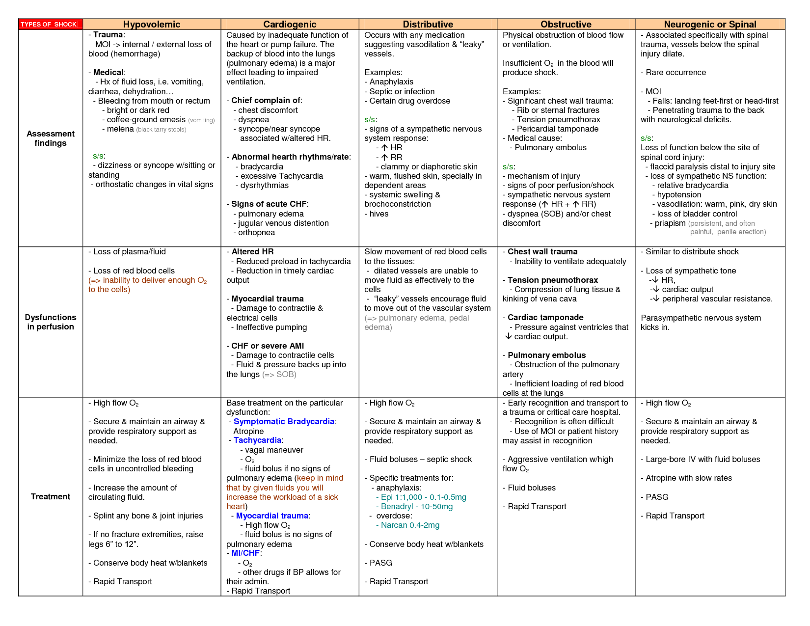

Cardiac Tamponade

Cardiac tamponade is defined as an accumulation of fluid in the pericardial sac, creating an increased pressure within the pericardial space that impairs the ability of the heart to fill and to pump.

Beck’s Triad
- Hypotension
- Elevated jugular venous pressure
- Muffled heart sounds

Management
A single fluid challenge is likely to be beneficial especially in the setting of hypotension (<100mmHg). Excess fluid administration risks worsening ventricular interdependence on the patient and decreasing their cardiac output.

Pericardiocentesis
- Placement of a catheter percutaneously into the pericardial sac in order to externally drain the effusion.
- Can use landmarks or under echo guidance
- Contraindicated in aortic dissection and relatively contraindicated in severe coagulopathy.

- A Seldinger technique is normally employed with a needle inserted between the xiphoid and left costal margin, angled at a 15-degree angle under the costal margin then slowly advanced towards the tip of the left scapula.
- A J-shaped guide can be threaded and a pigtail-catheter railroaded into place if required.
- ECG monitoring is required as instrumentation of the heart can provoke ectopic beats or ventricular arrhythmias.

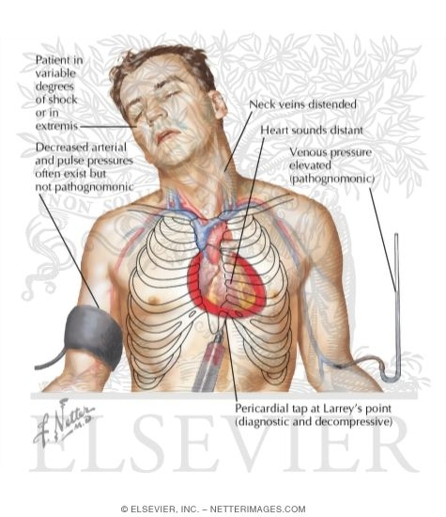

Surgical drainage

Emergency sternotomy is indicated in tamponade with incipient cardiac arrest.
Emergency thoracotomy equipment should be available in these locations.
A small sub-xiphoid incision is made, which may relieve some of the pericardial pressure prior to direct visualisation and incision of the parietal pericardium.
Drainage of fluid and control of bleeding within the pericardium can then occur.
Cardiopulmonary bypass equipment and a trained perfusionist should ideally be present.

AMI

O2
ABCDs

APO

Fluid overload
Cardiogenic edema
Neurogenic edema
Acute lung injury
Allergic reaction
Upper airway obstruction

SIGNS AND SYMPTOMS
Respiratory distress/tachypnoea
Desaturation
Increased inspiratory pressure
Pink frothing sputum up ETT / LMA (diagnostic)
Crepitations or bronchospasm

PRECIPITATING FACTORS
Fluid overload
Non cardiogenic:
- Post airway obstruction
- Anaphylaxis
- Neurogenic Sepsis
- Pulmonary aspiration
- Multiple organ failure
Cardiogenic

EMERGENCY MANAGEMENT
Titrate inspired oxygen concentration against SpO2
Head up tilt / sit up if possible
If breathing spontaneously apply CPAP
Intubate if necessary
IPPV and PEEP if intubated
Consider drug therapy: - morphine / GTN / frusemide (6)

FURTHER CARE
Consider and investigate likely cause.
Chest X-ray
Review peri-operative fluid balance/renal function
Non-cardiogenic: consider following
airway obstruction
Allergy/anaphylaxis
Aspiration
Sepsis
Multiple organ failure, e.g. major trauma, pancreatitis Renal - renal function tests

Aortic Dissection

Stanford classification
Type A - ascending aorta but may extend into the arch and descending aorta (DeBakey type I and II).
Type B - the descending aorta only (DeBakey type III).

- Tachycardia, usually accompanied by hypertension in the setting of baseline primary hypertension and increased catecholamine levels from anxiety and pain.
- Tachycardia and hypotension result from aortic rupture, pericardial tamponade, acute aortic valve regurgitation, or even acute myocardial ischaemia with involvement of the coronary ostia.

- Differential or absent pulses in the extremities and a diastolic murmur of aortic regurgitation may also be present. Syncope, stroke, and other neurological manifestations secondary to malper- fusion syndrome may develop.

Management
The primary goal is to reduce the force of left ventricular contraction without compromising perfusion, thus reducing shear forces and preventing further extension of the dissection or possible rupture.

- Beta-blockers (e.g. esmolol, metoprolol) and labetalol (beta- and alpha-blocker) can be used.
- If further reduction in BP is required:
  - sodium nitroprusside,
  - glyceryl trinitrate,
  - hydralazine

Beta-blockers should be given first before vasodilators, as the reflex catecholamine release due to vasodilatation may increase left ventricular contractions.

- Oxygen (ABC as indicated)
- Detailed medical history and complete physical examination (whenever possible)
- HR, BP, and SpO2 monitoring
- i.v. line, bloods (Cross match, CK, Troponin, FBC, U & Es, Myoglobin, D-dimer,
- LDH)
- 12-lead ECG: documentation of ischaemia
- Pain relief (morphine sulphate)
- Careful i.v. fluid infusion BP titration to about 110–120 mm Hg systolic with i.v. esmolol, metoprolol, or labetalol first.
- Sodium nitroprusside for further control of blood pressure (calcium channel blockers if beta-blockers are contraindicated)
- Imaging studies at the earliest opportunity
- Transfer to theatre/regional cardiothoracic centre/intensive care unit as appropriate

Bronchospasm

SIGNS AND SYMPTOMS
Increasing circuit pressure
Desaturation Wheeze (auscultate)
Rising ETCO2 and prolonged expiration
Reduction in tidal volumes

THINK OF
Anaphylaxis/allergy to drugs / IV fluids / latex
Airway manipulation / irritation / secretions / soiling Oesophageal/endobronchial intubation
Pneumothorax
Inadequate anaesthetic depth or failure of anaesthetic delivery system

EMERGENCY MANAGEMENT
- 100% Oxygen
- Cease stimulation/surgery
- Request immediate assistance
- Deepen anaesthesia
- If intubated exclude endobronchial or oesophageal position
- If mask/LMA in use consider early:
  - Laryngospasm/Airway obstruction
  - Regurgitation/vomit/aspiration
- Give adrenaline or salbutamol
  - Adult salbutamol: 0.5% 1ml (5mg) solution nebulised or aerosol puffer, 2 puffs (0.1 mg/puff), or 0.5% 0.1ml in 1 ml, injected down ETT (0.5mg)
  - Child salbutamol nebuliser: 1 year – 1.25mg; 5-10 years – 2.5mg.
  - Adrenaline IV: 1 mcg / kg bolus (0.01 ml/kg of 1:10,000 soln.) slowly.
    - Repeat bolus, or commence infusion 0.15 mcg / kg / min. Titrate to heart rate, blood pressure, and bronchodilator effect.
- If you cannot ventilate via an ETT consider: Misplaced/kinked/blocked ETT or circuit ➠ CHECK
  - Pneumothorax
  - Aspiration
  - Anaphylaxis
  - Pulmonary oedema
- Consider possible obstruction distal to ETT
- Try pushing a small tube past it, or push the obstruction down one bronchus and ventilate the other lung.

Tension Pneumothorax

SIGNS AND SYMPTOMS
Difficulty with ventilation/respiratory distress
Desaturation
Hypotension
Heart rate changes
Unilateral chest expansion

Expose, inspect, palpate
Auscultate, percuss
Abdominal distension
Distended neck veins,
Raised CVP
Tracheal deviation

PRECIPITATING FACTORS
Any needle or instrumentation, even days previously in or near the neck or chest wall, Down the trachea / bronchial tree
External cardiac compression
Fractured ribs, crush injury
Blunt trauma / deceleration injury
Problem with pleural drain already sited
Airway overpressure, obstructed ETT
Emphysema or bullous lung disease

EMERGENCY MANAGEMENT
- Inform the surgeon
- Inspect the abdomen, or the diaphragm from below if visible
- Insert an IV cannula into the affected side
  - 2nd intercostal space mid clavicular line
- Turn off the nitrous oxide
- Insert a pleural drain at the same site
  - 5th intercostal space mid axillary line
- Continuously observe the bottle for bubbling and/or swinging
- Be vigilant for further deterioration in the patient, it may be due to:
  - Increased or continuing air leak Kinked / blocked / capped / clamped underwater seal drain
  - Contralateral pneumothorax
  - Misplaced pleural drain tip
  - Trauma caused by drain insertion
  - Misconnection of drain apparatus

Raised ICP
Signs and symptoms
- Headache
- Vomiting
- Nausea
- Papilledema
- Neurological deficits

ABC approach
Airway
Intubate, if not already done so.
Cervical spine protection (trauma patients) with in-line immobilization. Avoid tight ETT ties as this will hamper venous drainage

Breathing
IPPV with hyperventilation to arterial PaCO₂ 4 - 4.5 kPa.
Maintain SpO₂ > 96% and PaO₂ > 12 kPa
Avoid coughing with sufficient sedation and muscle relaxation

Circulation
Hypotension is the biggest cause of secondary brain injury and should be treated aggressively.
Maintain CPP > 70 mmHg (MAP > 90), with fluid initially and commence vasopressors if necessary.
Invasive arterial blood pressure and central venous pressure monitoring. Urinary catheter to monitor urine output and especially if mannitol is used.

Drugs
Adequate sedation, propofol infusion
Muscle relaxation
Mannitol 0.25 – 0.5 g/kg
Hypertonic saline (NaCl 3%) 1 – 2 ml/kg
Thiopentone may be considered in severe cases
Paracetamol for raised temperature

Exposure
Maintain normothermia and especially avoid hyperthermia as this will increase the CMRO₂.
Mild hypothermia may be protective, but extreme levels will exacerbate a coagulopathy and bleeding.
A 30º head-up position will improve venous drainage.

Fluids
Maintenance fluids should be given judiciously, so as not to exacerbate cerebral oedema.
Isotonic saline is preferred to glucose containing solutions, aiming to keep the serum sodium above 135 mmol/l.

Glucose
Maintain normoglycaemia with insulin if necessary.

Haematology

Ensure that haemoglobin is adequate to optimize the oxygen content of blood.
Correct any coagulopathy in event of intracranial bleeding.

Investigations
Urgent CT scan for neurosurgical review.
Routine blood tests including, FBC, clotting studies, U&Es, arterial blood gas and cross-match blood for theatre.

Prolonged Seizure

Status Epilepticus
Definition
- Continuous seizure activity lasting >30 min
Or
- Intermittent seizure activity lasting >30 min during which consciousness is not regained

Emergency Management
- ABC-
  - Airway
  - Breathing - 100% O2
  - Circulation - IV access
  - Don't Ever Forget Glucose! - check and correct hypoglycaemia

- First line therapy
  - IV Benzodiazepines - Lorazepam (0.1mg/kg) or Diazepam (0.1mg/kg), Midazolam (0.1mg/kg)

- Second line therapy if seizures not terminated within 10min
  - IV Phenytoin (15-17mg/kg) by slow infusion (rate <50mg/min)

- Intubation and ventilation to maintain normal PaO₂ and PaCO₂
  - Rapid Sequence Induction should be performed (although propofol is an acceptable substitute for thiopentone in this instance)

- Fluid resuscitation to maintain adequate systemic blood pressure and cerebral perfusion pressure

- If seizures are not controlled after 30 minutes with second line therapy, consider propofol or low dose thiopentone infusion anaesthesia preferably under EEG control.

- Remember - muscle relaxants stop the seizure movements, but not the abnormal cerebral activity, therefore in the paralysed patient, anticonvulsants are also essential.

Anaphylaxis

SIGNS AND SYMPTOMS
- Cardiovascular changes
  - Hypotension, circulatory collapse
  - Tachy - OR bradycardia
- Respiratory changes
  - Bronchospasm
  - Pulmonary oedema
- Erythema / skin rash / pruritus
- Oedema of the face and lips
- Nausea and vomiting in awake patients

PRECIPITATING FACTORS
Allergic reaction to drugs, colloids, blood products, latex allergy

EMERGENCY MANAGEMENT
Complete COVER ABCD - A SWIFT CHECK
Do not hesitate to treat as Cardiac Arrest
Inform the surgeon
Request immediate assistance
Cease all drugs/plasma expanders/blood products
Immediate and aggressive volume expansion
Maintain ventilation with 100% oxygen
Elevate the legs, if practical
Give adrenaline bolus IV 0.001mg/kg (adult dose 1 ml of 1:10,000)
Start adrenaline infusion 0.00015mg/kg/min (adult dose 1 ml/min of 1 mg in 100 ml), and increase as necessary
Administer slowly and titrate against heart rate and blood pressure

FURTHER CARE
The patient may relapse
Continue the adrenaline infusion, for days if necessary
Consider other drugs
Admit to HDU/ICU
Take bloods for testing as soon as possible
Counsel the patient/relatives.
Provide written advice and document this in the medical record
Arrange for allergy testing at 1 month

Malignant Hyperthermia

SIGNS AND SYMPTOMS
Early signs:
- Skeletal muscle rigidity (e.g. masseter spasm)
- Tachycardia and hypertension
- Elevated ETCO2
- Dysrhythmias
- Acidosis (metabolic and respiratory)

Late signs:
- Hyperpyrexia (may be >42oC)
- Central cyanosis despite high FIO2
- Electrolyte abnormalities
- Elevated CPK (>20000)
- Myoglobinuria
- Coagulopathy
- Cardiac failure/pulmonary oedema

HIGH RISK PATIENTS
Family history of MH
Use of suxamethonium and halothane
Certain musculo-skeletal syndromes

EMERGENCY MANAGEMENT
- Cease volatile agent
- Hyperventilate with 100% oxygen - use high flow rates
- Inform the surgeon
- Cease surgery as soon as possible
- Request immediate assistance
- Obtain Dantrolene from the emergency trolley or on-site
- Monitor body temperature
- Take sample for arterial blood gas (ABG)
- Consider sodium bicarbonate 50mEq if ABG unavailable
- Give dantrolene 200mg (4 mg/kg) IV
- Cool patient by all available routes:
  - Surface
  - Body cavity irrigation (i.e. nasogastric/rectal lavage)
  - Cold IV fluids
- Change anaesthetic tubing and soda lime
- Consider invasive monitoring

FURTHER CARE
- FIO2 = 1.0 at all times until condition resolved
- Titrate further dantrolene against the clinical response
- Place intra-arterial cannula for frequent blood sampling:
  - Blood gases Electrolytes (K+ Ca++)
  - Clotting studies
- Place a urinary catheter, aim for urine output ≥ 1ml/kg/hr

There is a chance of relapse:
Observe in HDU/ICU for at least 24 hours
Continue dantrolene for at least 48 hours
Arrange for MH testing in the future

PE
Gas Embolism
Coagulopathy

Primary Survey

The ABCDE survey (Airway, Breathing, Circulation, Disability and Exposure) is undertaken as the Primary survey.
This primary survey must be performed in no more than 2–5 minutes. Simultaneous treatment of injuries can occur when more than one life-threatening state exists.
It includes:

Airway
- Assess the airway.
- Can patient talk and breathe freely?
- If obstructed, the steps to be considered are:
  - C hin lift/jaw thrust (tongue is attached to the jaw)
  - suction (if available)
  - guedel airway/nasopharyngeal airway
  - Intubation. NB keep the neck immobilised in neutral position.

Breathing
Breathing is assessed as airway patency and breathing adequacy are re-checked.
If inadequate, the steps to be considered are:
- decompression and drainage of tension pneumothorax/haemothorax
- closure of open chest injury
- artificial ventilation.

Give oxygen if available.
Reassessment of ABC’s must be undertaken if patient is unstable

Circulation
Assess circulation, as oxygen supply, airway patency and breathing adequacy are re-checked.
If inadequate, the steps to be considered are:
- Stop external haemorrhage
- Establish 2 large-bore IV lines (14or16G) if possible
- administer fluid if available

Disability
Rapid neurological assessment (is patient awake, vocally responsive to pain or
unconscious).
There is no time to do the Glasgow Coma Scale so a AVPU system at this stage is clear and quick.

A – awake
V – verbal response
P – painful response
U – unresponsive

Exposure
Undress patient and look for injury.
If the patient is suspected of having a neck or spinal injury, in-line immobilization is important.

